**Late Submissions will not be accepted**

Q1- Write a program in C++ to check whether a number can be expressed as the sum of two prime numbers.

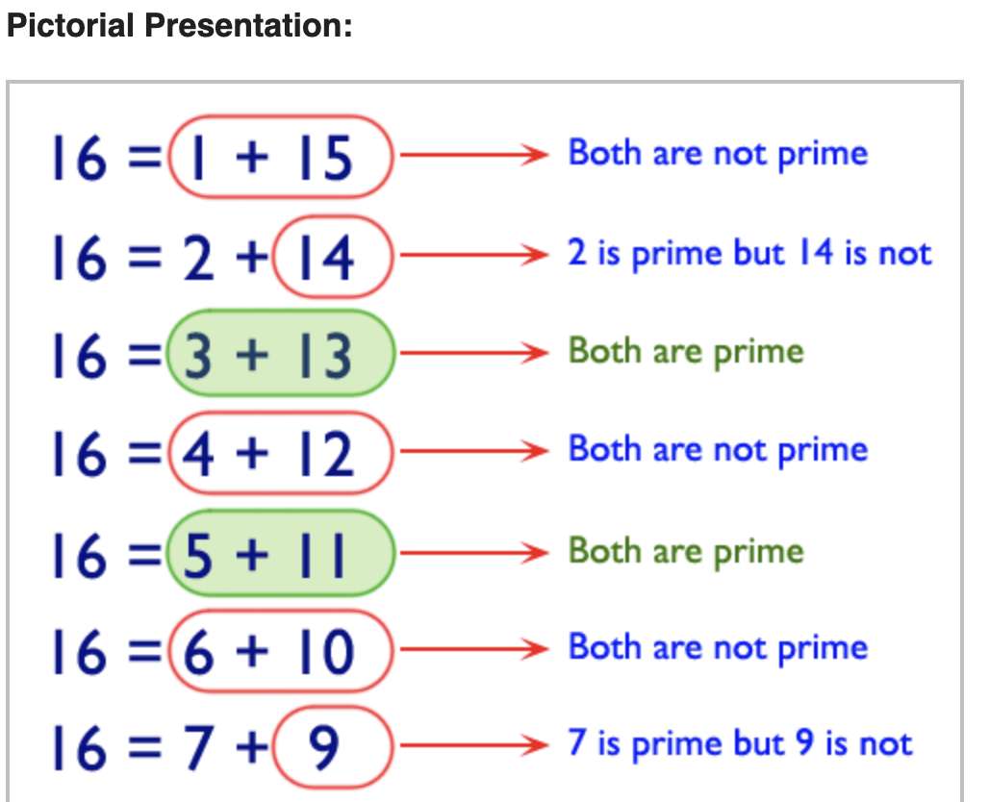

Q 2,3,4 - Write a program to draw the following pattern. You need to input rows.

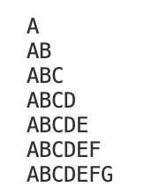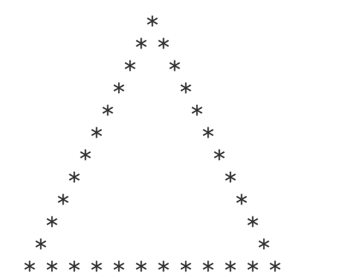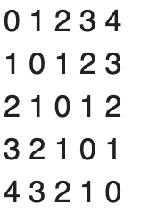

Q5- Write a program to draw the following pattern. You need to input the ODD number of rows.

**Sample Output** (for rows = 5)

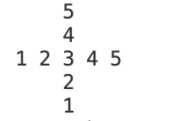

Q6- Write a program to draw the following pattern. You need to input the number.

**Sample Output** (for number = 4)

